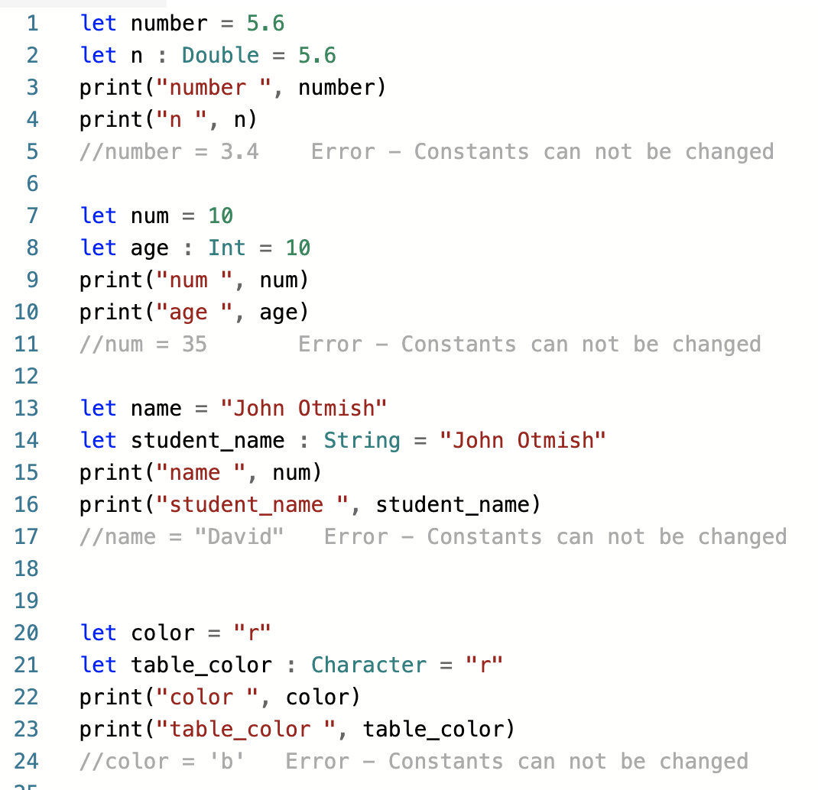

let number = 5.6

let n : Double = 5.6

print("number ", number)

print("n ", n)

//number = 3.4 Error - Constants can not be changed

let num = 10

let age : Int = 10

print("num ", num)

print("age ", age)

//num = 35 Error - Constants can not be changed

let name = "John Otmish"

let student_name : String = "John Otmish"

print("name ", num)

print("student_name ", student_name)

//name = "David" Error - Constants can not be changed

let color = "r"

let table_color : Character = "r"

print("color ", color)

print("table_color ", table_color)

//color = 'b' Error - Constants can not be changed